SEASHELL – CANDIDATE APPLICATION FORM
Please note that you are applying for a zero-hour contract. If you are successful in your application please be aware that your preferred hours of work will take time to build up, we look to match clients and carers to build long-term working relationships and grow the workload based on experience and want.

This form is editable, just click and type in the appropriate text box. If you have any questions when completing this form please contact SeaShell on 01992 874688 or info@seashellcare.com.
Full name
Current address
(Including postcode)
Telephone number
(Home and mobile)
Email
Own transport |  | Please select -
How long has your licence been held?
Are you a United Kingdom (UK) or Irish National? |  | Please select -  If no, please detail current immigration status and the relevant visa currently held (including visa number)
National Insurance Number
Are you are related to a member of staff or Client at SeaShell? |  | Please select -
Equality Act 2010
Under the Equality Act 2010 the definition of disability is if you have a physical or mental impairment that has a “substantial” and “long term adverse effect” on your ability to carry out normal day-to-day activities. Further information regarding the definition of disability can be found at: www.gov.uk/definition-of-disability-under-equality-act-2010.

For the purposes of this application and the interview stage only, is there anything you would like us to be aware of so that we can make reasonable adjustments during the process?

Please select -
Education
School/College/University |  | Examinations passed, qualifications gained and year obtained  (All qualifications will be subject to a satisfactory check)
Training Courses Attended or Completing |  | Examinations passed, qualifications gained and year obtained  (All qualifications will be subject to a satisfactory check)
Employment History
(Last five years plus any relevant work experience)
Name and address of your most recent/last employer
Start and end date |  | Start: 01/01/2021, End: 01/01/2021
Position held and reason for leaving
Name and address of your most recent/last employer
Start and end date
Position held and reason for leaving
Name and address of your most recent/last employer
Start and end date |  | Start: 01/01/2021, End: 01/01/2021
Position held and reason for leaving
Name and address of your most recent/last employer
Start and end date |  | Start: 01/01/2021, End: 01/01/2021
Position held and reason for leaving
Please detail here any gaps in employment and state why:

Supporting Statement
What makes you a good carer? Please add here your reasons for applying. It would also be of value to describe particular strengths and talents that set you apart from others as well as including skills gained from work, home and other activities.
Availiability
Number of hours required per week?

SeaShell services runs from 07.00 – 22.00 and we see clients for 1 hour calls as a minimum. If you are successful in your application please be aware that your hours of work will take time to build up, we look to match clients and carers to build long-term working relationships and grow the workload based on experience and want.
Preferred times of work

We understand the need for flexibility and have shift patterns to reflect this. For continuity for our clients, we expect you to be available for the same times during the week and the weekend. SeaShell carers are expected to work every other weekend. If our shift patterns do not suit your personal circumstances then please indicate what your availability is.

Please select YES if you are available for this shift or NO if you are not available next to the shift times below.
07.00 – 14.30 |  |  |  | 14.30 – 22.00
07.00 – 12.00 |  |  |  | 12.00 – 17.00
17.00 – 22.00 |  |  |  | 09.30 – 14.30
07.00 – 09.30 |  |  |  | 19.30 – 22.00
Other (please provide details)
For further information on our care call times and typical busy periods, please refer to the table below.
Busy  07.00 – 08.00  08.15 – 09.15  09.30 – 10.30  12.00 – 13.00  13.15 – 14.15  18.15 – 19.15  19.30 – 20.30  20.45 – 21.45 |  |  |  | Quiet  10.45 – 11.45  14.30 – 15.30  15.45 – 16.45  17.00 – 18.00
Referees
You must provide references from your two most recent employers. Please provide a character reference if you are unable to obtain two professional references, e.g. in the case of an applicant who has been raising children for ten years. All will be contacted, therefore please inform the referees of the fact that you have used their name. If you are unable to provide the required references, please discuss the matter with us.
Current or most recent employer name
Address
Postcode
Tel no
Email
Contact name and job title
Previous employer name to the one above
Address
Postcode
Tel no
Email
Contact name and job title
Character reference name
(only required if you cannot provide two employment referees)
Address
Postcode
Tel no
Email
Relationship to you
Safeguarding - Ex-Offenders Declaration
Please note this section will only be seen by those involved in the recruitment process and will be treated with the strictest of confidence.
Rehabilitation of Offenders Act 1974
SeaShell aims to promote equality of opportunity and is committed to treating all applicants fairly regardless of ethnicity, disability, age, gender or gender re-assignment, religion or belief, sexual orientation, pregnancy or maternity and marriage or civil partnership. SeaShell undertakes not to discriminate unfairly against applicants on the basis of a criminal conviction or other information declared. Answering 'yes' to the question below will not necessarily prevent your employment. This will depend on the relevance of the information you provide in respect of the nature of the position and the particular circumstances.
Are you currently bound over or do you have any current UNSPENT convictions that have been issued by a Court or Court-Martial in the United Kingdom or in any other country?

Please select -

Do you have any current UNSPENT police cautions, reprimands or final warnings in the United Kingdom or in any other country?

Please select -
SeaShell will only collect data for specified explicit and legitimate use in relation to the recruitment process. By signing this application form, you consent to SeaShell holding the information contained within this application form. If successfully shortlisted, data will also include shortlisting scoring and interview records. We would like to keep this data until the vacancy is filled. (We cannot estimate the exact time period, but we will consider this period over when a candidate accepts our job offer for the position for which we are considering you). When that period is over, we will either delete your data or inform you that we would like to keep it in our database for future roles. We have privacy policies that you can request for further information. Please be assured that your data will be securely stored by the Registered Manager and only used for the purposes of recruiting for this vacant post. You have a right for your data to be forgotten, to rectify or access data, to restrict processing, to withdraw consent and to be kept informed about the processing of your data. If you would like to discuss this further or withdraw your consent at any time, please contact contact SeaShell on 01992 874688 or info@seashellcare.com.
Declaration
The information in this application form is true and complete. I agree that any deliberate omission, falsification or misrepresentation in the application form will be grounds for rejecting this application or subsequent dismissal if employed by SeaShell. Where applicable, I consent that SeaShell can seek clarification regarding professional registration details.
Name |  |  |  | Date 01/01/2021
Signature
You can type in your signature

A Question of Care: A Career for YOU?
We ask all SeaShell candidates to try this interactive video challenge ‘A Question of Care: a Career for YOU’ to see what a career in care is like. At the end you`ll receive a detailed personal profile that tells you if you’ve got what it takes to join our team! Please include this feedback in your application email (see below for more details).

Instructions

- Please complete the questionnaire at www.aquestionofcare.co.uk and select the ‘Jean - residential care service’ and ‘Jackie – community/domiciliary care’ scenarios (see below highlighted in red):

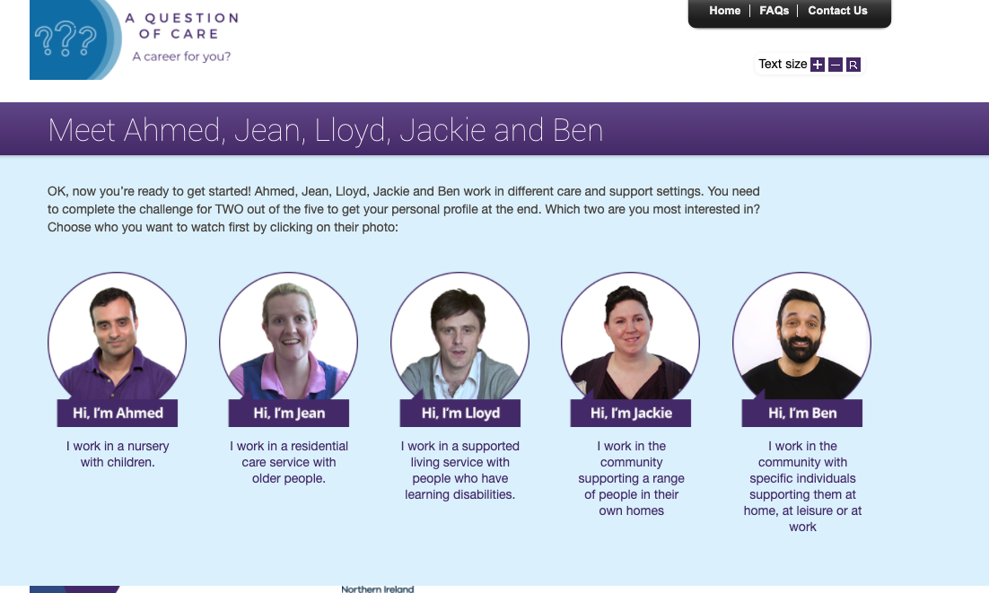

- Once complete, please download or email the feedback to yourself (see below) and attach it to the email with your application.

